DBSCAN Clustering Results
Generated: 2026-05-27 20:22:47

Parameters
Index | Parameter | Value
0 | Epsilon (eps) | 0.5
1 | Min Samples | 5
2 | Metric | euclidean
3 | Standardized | True
4 | Variables Used | CustomerID, Age, AnnualIncome, SpendingScore
5 | Observations | 200

Clustering Results
Index | Metric | Value
0 | Number of Clusters | 2
1 | Noise Points | 64
2 | Noise Percentage | 32.0%

Cluster Sizes
Index | Cluster | Count | Percentage
0 | 0 | 5 | 2.5%
1 | 1 | 131 | 65.5%

Fit Measures
Index | Metric | Value | Interpretation
0 | Silhouette Score | 0.5719872350537292 | Closer to 1 is better
1 | Davies-Bouldin Index | 0.4279112151164004 | Lower is better
2 | Calinski-Harabasz Score | 41.39825828378057 | Higher is better

Cluster Assignments
Index | CustomerID | Age | AnnualIncome | SpendingScore | Cluster | Is_Noise
0 | 1 | 19 | 15000 | 39 | -1 | True
1 | 2 | 21 | 35000 | 81 | -1 | True
2 | 3 | 20 | 86000 | 6 | -1 | True
3 | 4 | 23 | 59000 | 77 | -1 | True
4 | 5 | 31 | 54000 | 40 | -1 | True
5 | 6 | 22 | 68000 | 76 | -1 | True
6 | 7 | 35 | 112000 | 6 | -1 | True
7 | 8 | 23 | 67000 | 94 | -1 | True
8 | 9 | 64 | 81000 | 91 | -1 | True
9 | 10 | 30 | 61000 | 15 | -1 | True
10 | 11 | 67 | 91000 | 77 | -1 | True
11 | 12 | 35 | 43000 | 13 | -1 | True
12 | 13 | 58 | 79000 | 70 | -1 | True
13 | 14 | 24 | 57000 | 58 | -1 | True
14 | 15 | 37 | 68000 | 92 | -1 | True
15 | 16 | 22 | 36000 | 8 | -1 | True
16 | 17 | 35 | 75000 | 79 | -1 | True
17 | 18 | 52 | 116000 | 3 | -1 | True
18 | 19 | 35 | 53000 | 71 | -1 | True
19 | 20 | 26 | 65000 | 88 | -1 | True
20 | 21 | 29 | 51000 | 16 | -1 | True
21 | 22 | 35 | 95000 | 79 | -1 | True
22 | 23 | 37 | 68000 | 78 | -1 | True
23 | 24 | 23 | 41000 | 62 | -1 | True
24 | 25 | 45 | 126000 | 70 | -1 | True
25 | 26 | 24 | 74000 | 62 | -1 | True
26 | 27 | 38 | 65000 | 69 | -1 | True
27 | 28 | 30 | 63000 | 51 | -1 | True
28 | 29 | 56 | 64000 | 62 | -1 | True
29 | 30 | 45 | 63000 | 70 | -1 | True
30 | 31 | 32 | 62000 | 69 | -1 | True
31 | 32 | 32 | 77000 | 52 | -1 | True
32 | 33 | 25 | 51000 | 70 | -1 | True
33 | 34 | 29 | 64000 | 69 | -1 | True
34 | 35 | 35 | 93000 | 80 | -1 | True
35 | 36 | 53 | 64000 | 63 | -1 | True
36 | 37 | 59 | 63000 | 72 | -1 | True
37 | 38 | 35 | 65000 | 50 | -1 | True
38 | 39 | 27 | 61000 | 81 | -1 | True
39 | 40 | 45 | 77000 | 72 | -1 | True
40 | 41 | 24 | 64000 | 62 | -1 | True
41 | 42 | 28 | 71000 | 70 | -1 | True
42 | 43 | 30 | 58000 | 58 | 0 | False
43 | 44 | 26 | 69000 | 80 | -1 | True
44 | 45 | 27 | 62000 | 66 | -1 | True
45 | 46 | 31 | 68000 | 83 | -1 | True
46 | 47 | 30 | 56000 | 60 | 0 | False
47 | 48 | 32 | 69000 | 68 | 1 | False
48 | 49 | 25 | 59000 | 70 | -1 | True
49 | 50 | 29 | 58000 | 55 | 0 | False
50 | 51 | 25 | 69000 | 70 | -1 | True
51 | 52 | 29 | 56000 | 54 | 0 | False
52 | 53 | 28 | 76000 | 74 | -1 | True
53 | 54 | 46 | 75000 | 76 | -1 | True
54 | 55 | 38 | 67000 | 58 | -1 | True
55 | 56 | 41 | 73000 | 78 | -1 | True
56 | 57 | 30 | 63000 | 59 | 1 | False
57 | 58 | 27 | 66000 | 71 | 1 | False
58 | 59 | 31 | 62000 | 68 | -1 | True
59 | 60 | 24 | 63000 | 61 | -1 | True
60 | 61 | 22 | 58000 | 60 | -1 | True
61 | 62 | 30 | 57000 | 61 | 0 | False
62 | 63 | 29 | 66000 | 58 | 1 | False
63 | 64 | 25 | 59000 | 56 | -1 | True
64 | 65 | 31 | 63000 | 70 | -1 | True
65 | 66 | 27 | 59000 | 61 | -1 | True
66 | 67 | 28 | 65000 | 62 | 1 | False
67 | 68 | 39 | 76000 | 78 | -1 | True
68 | 69 | 31 | 85000 | 75 | -1 | True
69 | 70 | 36 | 72000 | 77 | -1 | True
70 | 71 | 32 | 68000 | 70 | 1 | False
71 | 72 | 26 | 75000 | 73 | -1 | True
72 | 73 | 29 | 62000 | 65 | 1 | False
73 | 74 | 31 | 63000 | 67 | -1 | True
74 | 75 | 37 | 74000 | 74 | -1 | True
75 | 76 | 33 | 61000 | 62 | -1 | True
76 | 77 | 28 | 67000 | 67 | 1 | False
77 | 78 | 30 | 69000 | 68 | 1 | False
78 | 79 | 27 | 70000 | 66 | 1 | False
79 | 80 | 29 | 68000 | 69 | 1 | False
80 | 81 | 31 | 71000 | 71 | 1 | False
81 | 82 | 28 | 69000 | 68 | 1 | False
82 | 83 | 32 | 71000 | 69 | 1 | False
83 | 84 | 29 | 73000 | 72 | 1 | False
84 | 85 | 31 | 72000 | 70 | 1 | False
85 | 86 | 33 | 70000 | 69 | 1 | False
86 | 87 | 27 | 68000 | 67 | 1 | False
87 | 88 | 28 | 69000 | 68 | 1 | False
88 | 89 | 30 | 71000 | 70 | 1 | False
89 | 90 | 29 | 70000 | 68 | 1 | False
90 | 91 | 31 | 69000 | 69 | 1 | False
91 | 92 | 28 | 71000 | 70 | 1 | False
92 | 93 | 30 | 72000 | 69 | 1 | False
93 | 94 | 29 | 70000 | 68 | 1 | False
94 | 95 | 31 | 69000 | 70 | 1 | False
95 | 96 | 28 | 71000 | 69 | 1 | False
96 | 97 | 30 | 70000 | 68 | 1 | False
97 | 98 | 29 | 69000 | 70 | 1 | False
98 | 99 | 31 | 71000 | 69 | 1 | False
99 | 100 | 28 | 70000 | 68 | 1 | False
100 | 101 | 30 | 69000 | 70 | 1 | False
101 | 102 | 29 | 71000 | 69 | 1 | False
102 | 103 | 31 | 70000 | 68 | 1 | False
103 | 104 | 28 | 69000 | 70 | 1 | False
104 | 105 | 30 | 71000 | 69 | 1 | False
105 | 106 | 29 | 70000 | 68 | 1 | False
106 | 107 | 31 | 69000 | 70 | 1 | False
107 | 108 | 28 | 71000 | 69 | 1 | False
108 | 109 | 30 | 70000 | 68 | 1 | False
109 | 110 | 29 | 69000 | 70 | 1 | False
110 | 111 | 31 | 71000 | 69 | 1 | False
111 | 112 | 28 | 70000 | 68 | 1 | False
112 | 113 | 30 | 69000 | 70 | 1 | False
113 | 114 | 29 | 71000 | 69 | 1 | False
114 | 115 | 31 | 70000 | 68 | 1 | False
115 | 116 | 28 | 69000 | 70 | 1 | False
116 | 117 | 30 | 71000 | 69 | 1 | False
117 | 118 | 29 | 70000 | 68 | 1 | False
118 | 119 | 31 | 69000 | 70 | 1 | False
119 | 120 | 28 | 71000 | 69 | 1 | False
120 | 121 | 30 | 70000 | 68 | 1 | False
121 | 122 | 29 | 69000 | 70 | 1 | False
122 | 123 | 31 | 71000 | 69 | 1 | False
123 | 124 | 28 | 70000 | 68 | 1 | False
124 | 125 | 30 | 69000 | 70 | 1 | False
125 | 126 | 29 | 71000 | 69 | 1 | False
126 | 127 | 31 | 70000 | 68 | 1 | False
127 | 128 | 28 | 69000 | 70 | 1 | False
128 | 129 | 30 | 71000 | 69 | 1 | False
129 | 130 | 29 | 70000 | 68 | 1 | False
130 | 131 | 31 | 69000 | 70 | 1 | False
131 | 132 | 28 | 71000 | 69 | 1 | False
132 | 133 | 30 | 70000 | 68 | 1 | False
133 | 134 | 29 | 69000 | 70 | 1 | False
134 | 135 | 31 | 71000 | 69 | 1 | False
135 | 136 | 28 | 70000 | 68 | 1 | False
136 | 137 | 30 | 69000 | 70 | 1 | False
137 | 138 | 29 | 71000 | 69 | 1 | False
138 | 139 | 31 | 70000 | 68 | 1 | False
139 | 140 | 28 | 69000 | 70 | 1 | False
140 | 141 | 30 | 71000 | 69 | 1 | False
141 | 142 | 29 | 70000 | 68 | 1 | False
142 | 143 | 31 | 69000 | 70 | 1 | False
143 | 144 | 28 | 71000 | 69 | 1 | False
144 | 145 | 30 | 70000 | 68 | 1 | False
145 | 146 | 29 | 69000 | 70 | 1 | False
146 | 147 | 31 | 71000 | 69 | 1 | False
147 | 148 | 28 | 70000 | 68 | 1 | False
148 | 149 | 30 | 69000 | 70 | 1 | False
149 | 150 | 29 | 71000 | 69 | 1 | False
150 | 151 | 31 | 70000 | 68 | 1 | False
151 | 152 | 28 | 69000 | 70 | 1 | False
152 | 153 | 30 | 71000 | 69 | 1 | False
153 | 154 | 29 | 70000 | 68 | 1 | False
154 | 155 | 31 | 69000 | 70 | 1 | False
155 | 156 | 28 | 71000 | 69 | 1 | False
156 | 157 | 30 | 70000 | 68 | 1 | False
157 | 158 | 29 | 69000 | 70 | 1 | False
158 | 159 | 31 | 71000 | 69 | 1 | False
159 | 160 | 28 | 70000 | 68 | 1 | False
160 | 161 | 30 | 69000 | 70 | 1 | False
161 | 162 | 29 | 71000 | 69 | 1 | False
162 | 163 | 31 | 70000 | 68 | 1 | False
163 | 164 | 28 | 69000 | 70 | 1 | False
164 | 165 | 30 | 71000 | 69 | 1 | False
165 | 166 | 29 | 70000 | 68 | 1 | False
166 | 167 | 31 | 69000 | 70 | 1 | False
167 | 168 | 28 | 71000 | 69 | 1 | False
168 | 169 | 30 | 70000 | 68 | 1 | False
169 | 170 | 29 | 69000 | 70 | 1 | False
170 | 171 | 31 | 71000 | 69 | 1 | False
171 | 172 | 28 | 70000 | 68 | 1 | False
172 | 173 | 30 | 69000 | 70 | 1 | False
173 | 174 | 29 | 71000 | 69 | 1 | False
174 | 175 | 31 | 70000 | 68 | 1 | False
175 | 176 | 28 | 69000 | 70 | 1 | False
176 | 177 | 30 | 71000 | 69 | 1 | False
177 | 178 | 29 | 70000 | 68 | 1 | False
178 | 179 | 31 | 69000 | 70 | 1 | False
179 | 180 | 28 | 71000 | 69 | 1 | False
180 | 181 | 30 | 70000 | 68 | 1 | False
181 | 182 | 29 | 69000 | 70 | 1 | False
182 | 183 | 31 | 71000 | 69 | 1 | False
183 | 184 | 28 | 70000 | 68 | 1 | False
184 | 185 | 30 | 69000 | 70 | 1 | False
185 | 186 | 29 | 71000 | 69 | 1 | False
186 | 187 | 31 | 70000 | 68 | 1 | False
187 | 188 | 28 | 69000 | 70 | 1 | False
188 | 189 | 30 | 71000 | 69 | 1 | False
189 | 190 | 29 | 70000 | 68 | 1 | False
190 | 191 | 31 | 69000 | 70 | 1 | False
191 | 192 | 28 | 71000 | 69 | 1 | False
192 | 193 | 30 | 70000 | 68 | 1 | False
193 | 194 | 29 | 69000 | 70 | 1 | False
194 | 195 | 31 | 71000 | 69 | 1 | False
195 | 196 | 28 | 70000 | 68 | 1 | False
196 | 197 | 30 | 69000 | 70 | 1 | False
197 | 198 | 29 | 71000 | 69 | 1 | False
198 | 199 | 31 | 70000 | 68 | 1 | False
199 | 200 | 30 | 69000 | 70 | 1 | False

Visualizations
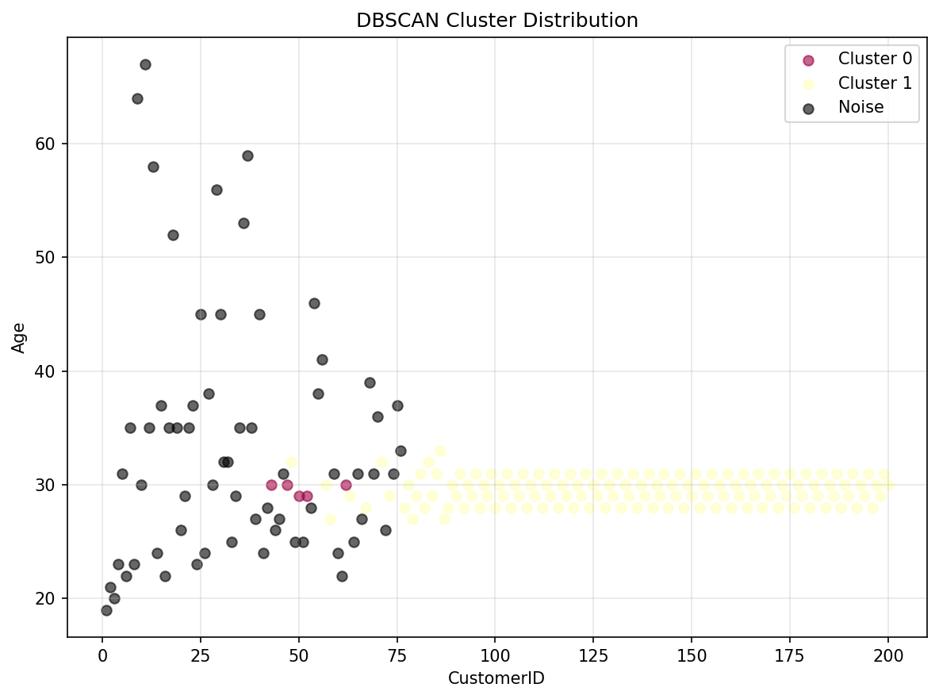
Figure 1

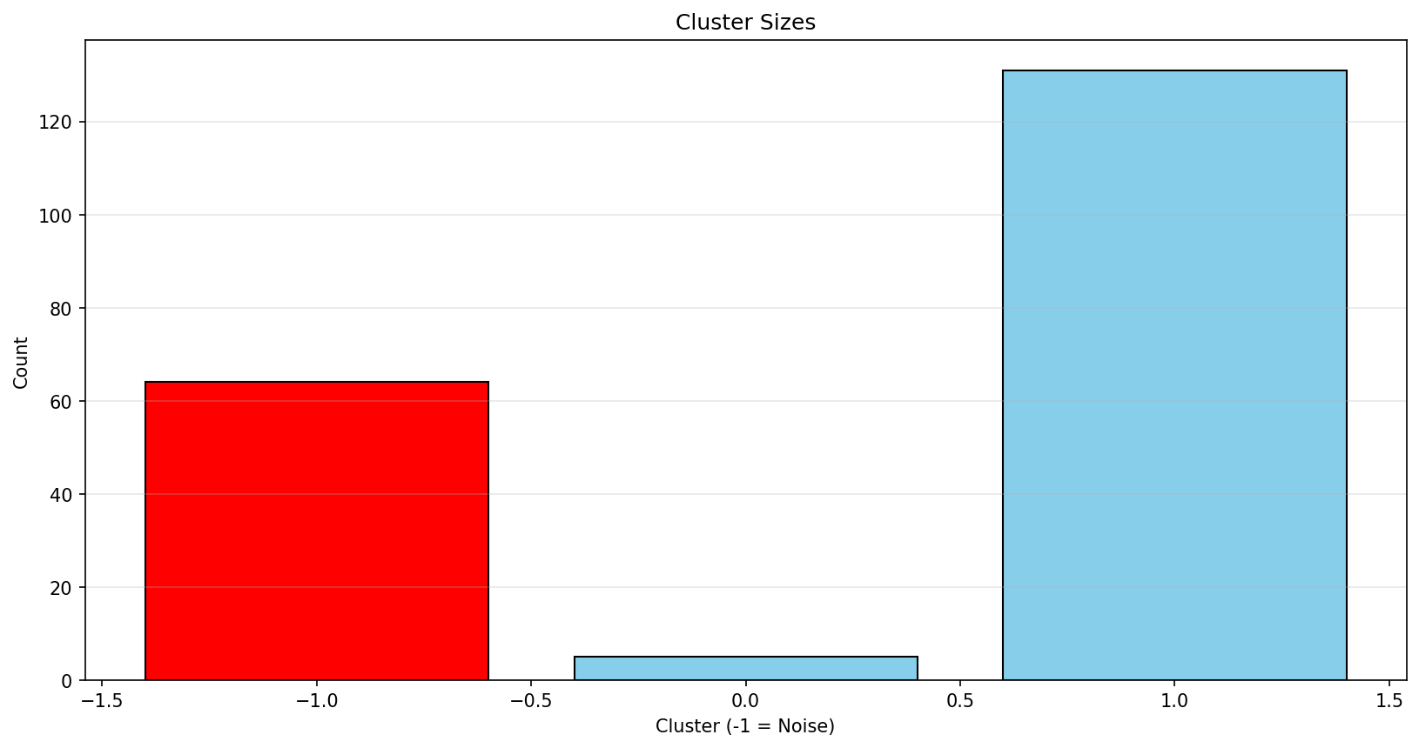
Figure 2

